CSC-234-0901

M2T1-exploring interactive fiction

Elizabeth Battenfield

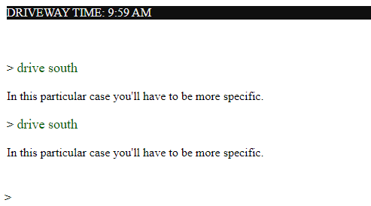

I gave up after after awhile not being able to get past the freeway option when driving. It’s a very simple game, but also challenging. You have to think of what you are doing step by step, and the clock is moving the more you type. I got stuck several times, until I realized what the baby step would be. I may have to continue playing this game in a little while to keep trying. I like how simple this game is, and it makes you think. You also have to remember things, because there is no scroll up option and the writing disappears to make room for more.